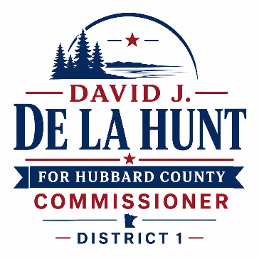FOR IMMEDIATE RELEASE 6/19/2026
De La Hunt: Fiscal Responsibility Requires Both Context and Action
As discussions continue about Hubbard County's budget and property taxes, it is important to separate perception from reality and provide residents with the facts behind recent budget decisions.
From 2023 through 2026, Hubbard County's levy increased from approximately $19.1 million to $22.9 million, representing an average annual increase of 4.6 percent. During that same period, inflation averaged approximately 3.4 percent annually. In other words, county spending grew by about 1.2 percentage points faster than inflation.
That increase deserves explanation.
A significant portion of recent budget growth has been driven by factors largely outside the County Board's direct control. Public safety costs have increased due to a full county jail, the loss of jail lease revenue from other counties, new mental health and health-related requirements imposed by the Minnesota Department of Corrections, and rising pay/ overtime expenses. Many of these requirements represent unfunded mandates from state government that local taxpayers are expected to absorb. An increase in staffing was required to meet these needs and mandates.
Similarly, Hubbard County's Human Services budget has experienced substantial growth because of increasing state mandates involving placement requirements, intake procedures, and other legally required services. These programs provide important services to vulnerable residents, but they often come without adequate state funding. An increase in staffing was required to meet these needs and mandates.
Inflation has also played a major role. Just as families have experienced higher costs for groceries, utilities, insurance, fuel and other items, county government has faced the same pressures. The unusually high inflation experienced in 2021(4.7%), 2022(8.0%), and 2023(4.1%) eventually translated into wage increases during labor negotiations. Because employee contracts typically cover multiple years, there is often a lag between inflationary pressures and the resulting budget impact. During the most recent negotiations, the County Board worked diligently to reach an agreement that compensates employees fairly based on the current market conditions.
Future budget pressures could come from Federal and State withholding of SNAP and Medicare and Medicaid funding. This is still fluid due to the fraud that has occurred in Minnesota and elsewhere. Other mandated programs include the Safe and Sick Time program and the MAAFPA (Mn African American Family Preservation Act) that where recently enacted by the Minnesota State Legislature without funding to cover all costs associated with implementation and operation.
There is also important good news for taxpayers.
While the county’s levy has increased, Hubbard County's tax capacity has grown significantly—from approximately $58 million to $75 million over the same period. Because tax capacity has increased faster than the levy, the county tax rate has declined. This means a portion of the additional levy has been absorbed by growth in the tax base, including new construction and development.
In addition, many lakeshore and other properties have experienced substantial increases in assessed value since 2023 due to strong real estate market conditions. State law requires counties to assess property values based on market conditions, and local officials do not control those market forces. As property values change, the distribution of the tax burden among taxpayers also changes. The good news is that assessed value growth has slowed substantially the past few years.
While there are legitimate reasons for recent budget growth, that does not mean we should accept continued increases without scrutiny. Going forward, Hubbard County must remain focused on responsible spending and long-term sustainability.
Key priorities should include:
- Holding county staffing levels as close as possible to current full-time equivalent (FTE) levels
- Identifying efficiencies, innovation, and creative solutions that reduce costs while maintaining essential services
- Continuing to carefully evaluate all spending requests and prioritize taxpayer value
- Continue to support policy that grows the tax capacity in the county
- Working with state legislators to limit, reform, or fully fund costly state mandates that are currently shifted onto local property taxpayers
Responsible government means recognizing the realities that drive costs while remaining committed to finding ways to control them. Hubbard County residents deserve both transparency and accountability, and those principles will continue to guide budget decisions in the years ahead.
David J. De La Hunt
Hubbard County Commissioner, District 1
Prepared and paid for by David J. De La Hunt on his own behalf.

